**Integrating SonarQube** **With Jenkins**

Manideep([pmanideep@deloitte.com](mailto:pmanideep@deloitte.com))

1. Create an AWS (Amazon Web Services) EC2 Instance with ubuntu image, (t2.small or higher configuration) instance type.



1. SSH (Secure Shell) into the Sonarqube_server

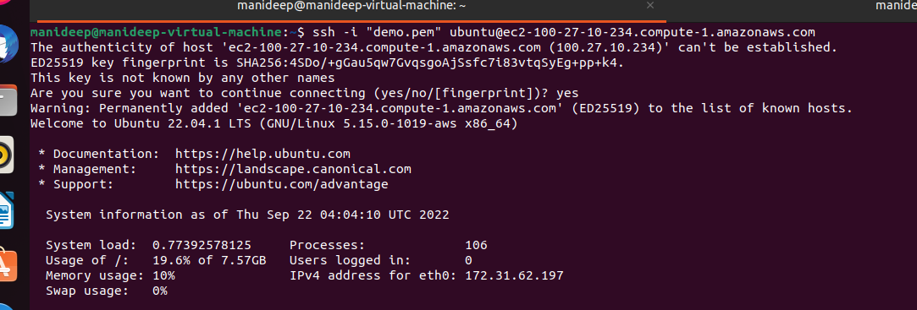

1. Switch to the root user ,update the “apt-get” package and install the “openjdk-11”

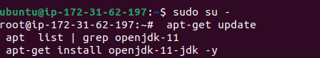

1. Install the PostgreSQL with “apt-get” package



1. Add the password (“admin”) to the “postgres” user and switch to the postgres user

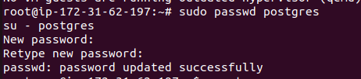

1. Create the user “sonar” and move into the postgres



1. Add the Encrypted password for the user “sonar”, create the database and grant all privileges to the user “sonar”

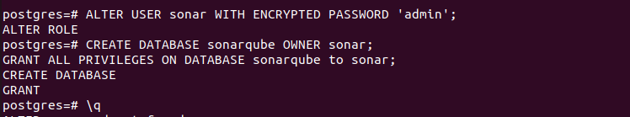

1. Logout from the postgres, restart and check the status of the PostgreSQL

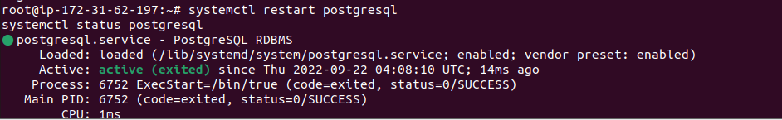

1. Install the “net-tools” package



1. Check whether postgres is running on its default port -5432

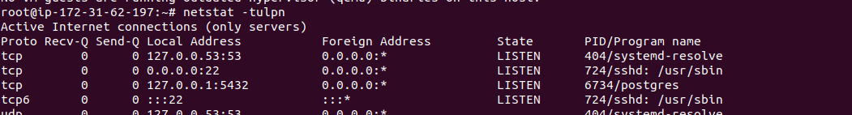

1. Add below entries in /etc/sysctl.conf

vm.max_map_count=524288

fs.file-max=131072

ulimit -n 131072

ulimit -u 8192

1. Add below entries in /etc/security/limits.conf

sonarqube - nofile 131072

sonarqube - nproc 8192

1. Reboot the Instance and connect back again and switch back to root user

**SonarQube Setup**

1. Download SonarQube and Extract it

wget https://binaries.sonarsource.com/Distribution/sonarqube/sonarqube-8.9.2.46101.zip

unzip sonarqube-8.9.2.46101.zip

1. Update sonar.properties with information below

sonar.jdbc.username=sonar

sonar.jdbc.password=admin

sonar.jdbc.url=jdbc:postgresql://localhost/sonarqube

sonar.search.javaOpts=-Xmx512m -Xms512m -XX:MaxDirectMemorySize=256m -XX:+HeapDumpOnOutOfMemoryError

1. Create a `/etc/systemd/system/sonarqube.service` file start sonarqube service at the boot time

cat >> /etc/systemd/system/sonarqube.service <<EOL

[Unit]

Description=SonarQube service

After=syslog.target network.target

[Service]

Type=forking

User=sonar

Group=sonar

PermissionsStartOnly=true

ExecStart=/opt/sonarqube/bin/linux-x86-64/sonar.sh start

ExecStop=/opt/sonarqube/bin/linux-x86-64/sonar.sh stop

StandardOutput=syslog

LimitNOFILE=65536

LimitNPROC=4096

TimeoutStartSec=5

Restart=always

[Install]

WantedBy=multi-user.target

EOL (End of Life)

1. Add sonar user and grant ownership to /opt/sonarqube directory

useradd -d /opt/sonarqube sonar

chown -R sonar:sonar

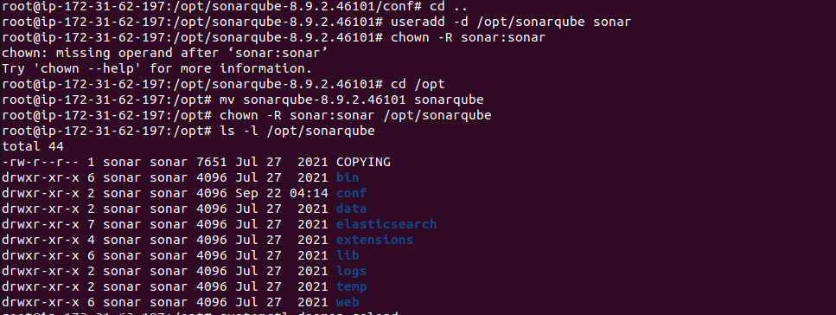

1. Reload the demon and start sonarqube service

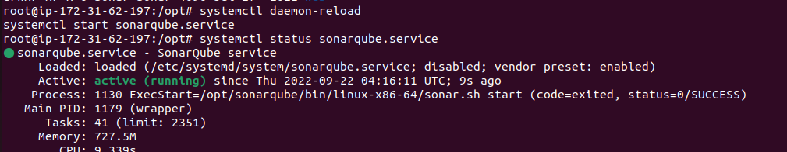

**Jenkins Setup**

1. Run the commands below on the terminal to install jenkins

curl -fsSL https://pkg.jenkins.io/debian-stable/jenkins.io.key | sudo tee \

/usr/share/keyrings/jenkins-keyring.asc > /dev/null

echo deb [signed-by=/usr/share/keyrings/jenkins-keyring.asc] \

https://pkg.jenkins.io/debian-stable binary/ | sudo tee \

/etc/apt/sources.list.d/jenkins.list > /dev/null

sudo apt-get update

sudo apt-get install jenkins

* Open the Jenkins on port-8080 and Sonarqube on port-9000

**On SonarQube Server**

* Add the project in the sonarqube and generate the secret token

**On Jenkins Server**

* Install Sonarqube plugin
* Configure Sonarqube credentials
* Add Sonarqube to jenkins "configure system"
* Install SonarScanner
* Create Pipeline job

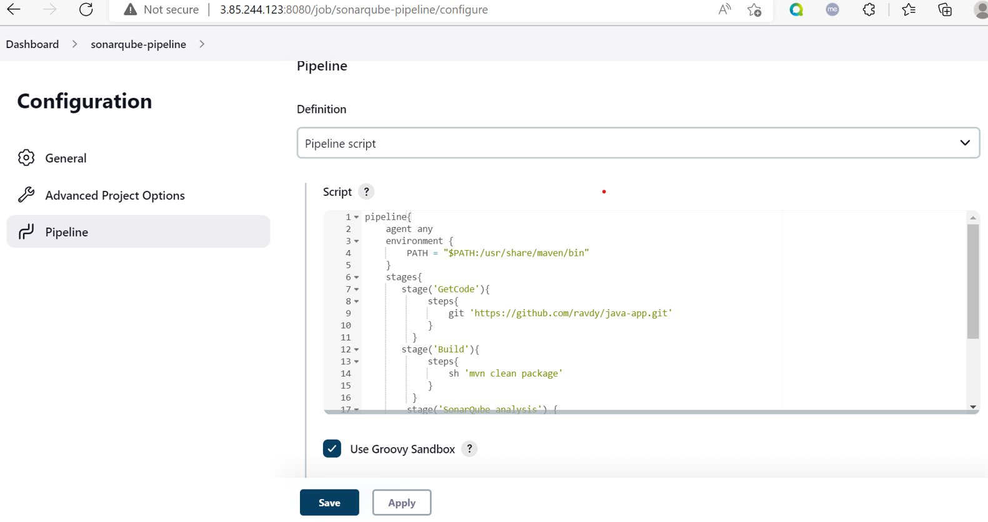

* Run the pipeline

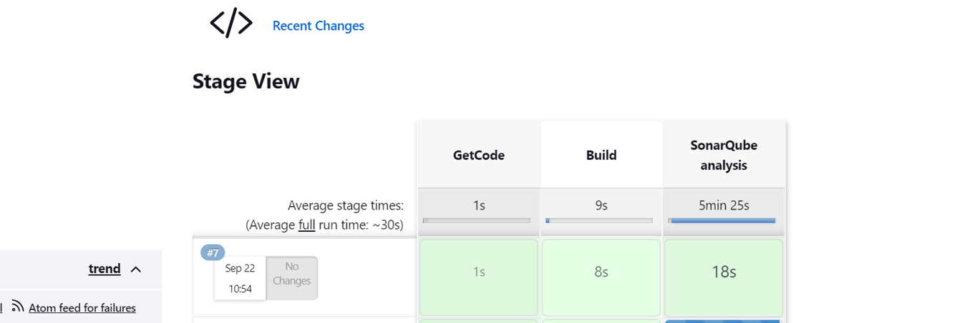

* Check the Dashboard on the SonarQube Server



